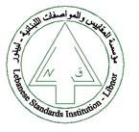

**The Lebanese Standards Institution**

Invites you to attend the

**“Good Manufacturing practices”**

**(مقدمة عن السلامة الغذائية و حسن ممارسة التصنيع)**

Training course

*Under the* ***Food safety training program***

*Offered by LIBNOR training center*



**Date: 26-27 June 2018 Time: 9h_ 15h**

**Companies are invited to contact us to register nominated candidate on**

[***training@libnor.org***](mailto:training@libnor.org)